 | Workshop  on  “High Power Fiber Laser:  Opportunities and Challenges”  26th – 27th February, 2020  Organised by  CSIR-Central Glass and Ceramic Research Institute, Kolkata |  | 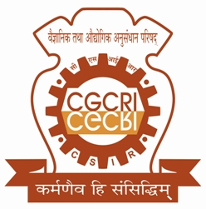
Name (in block letters)
Designation
Affiliation
Transaction Amount*
Transaction ID
Transaction Date
*Please mention ‘HPFL-2020’ during payment.
Fully filled form with signatures should be sent to ‘convenor.hpfl@gmail.com’.

Date:
____________________________
Signature of the Participant

____________________________
Signature of HOD/ Supervisor

