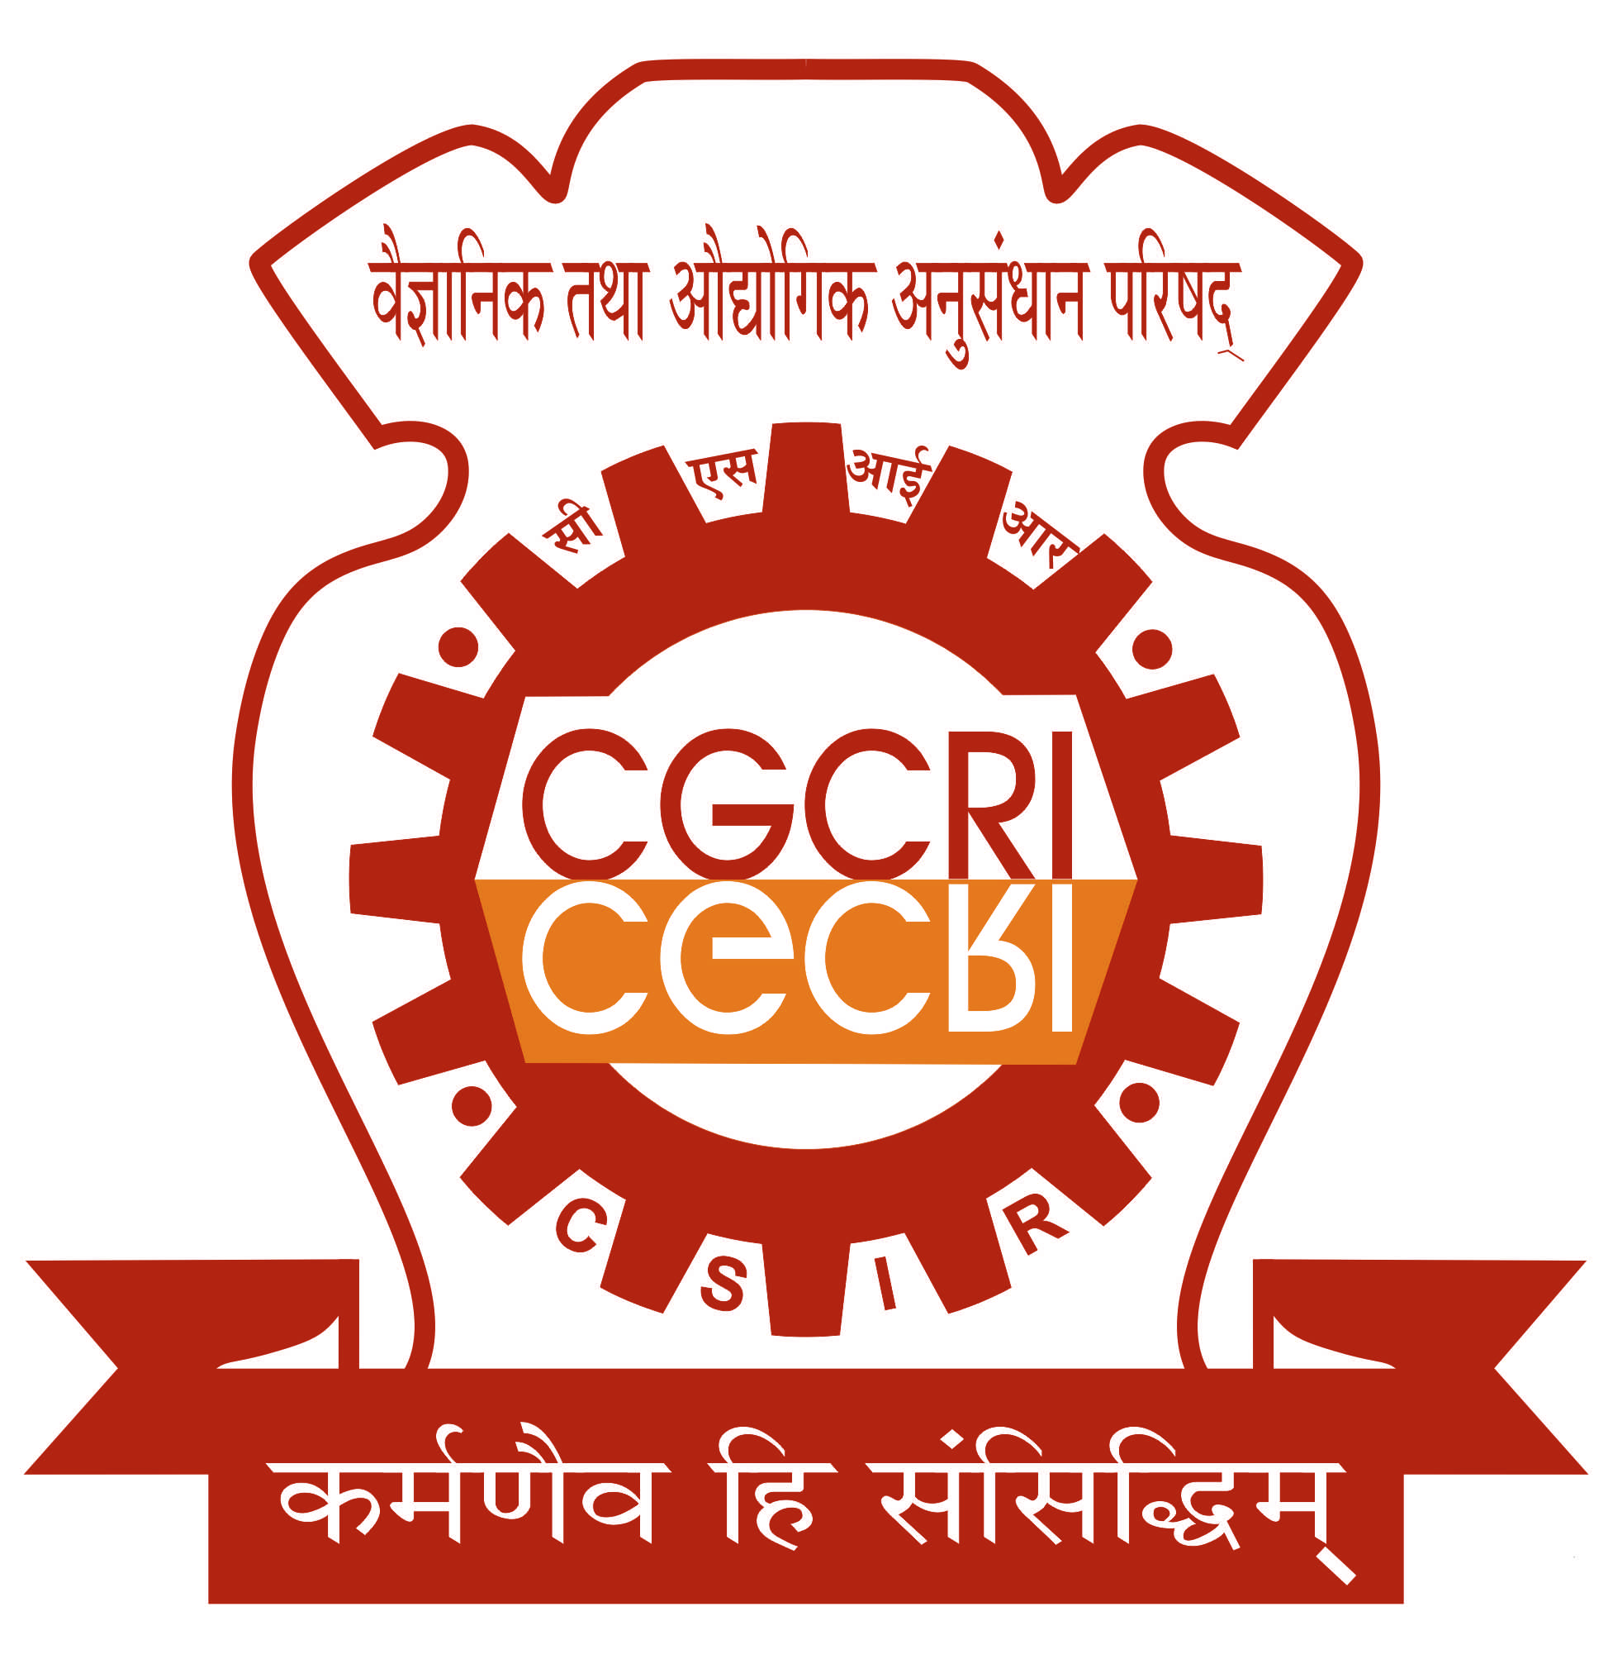
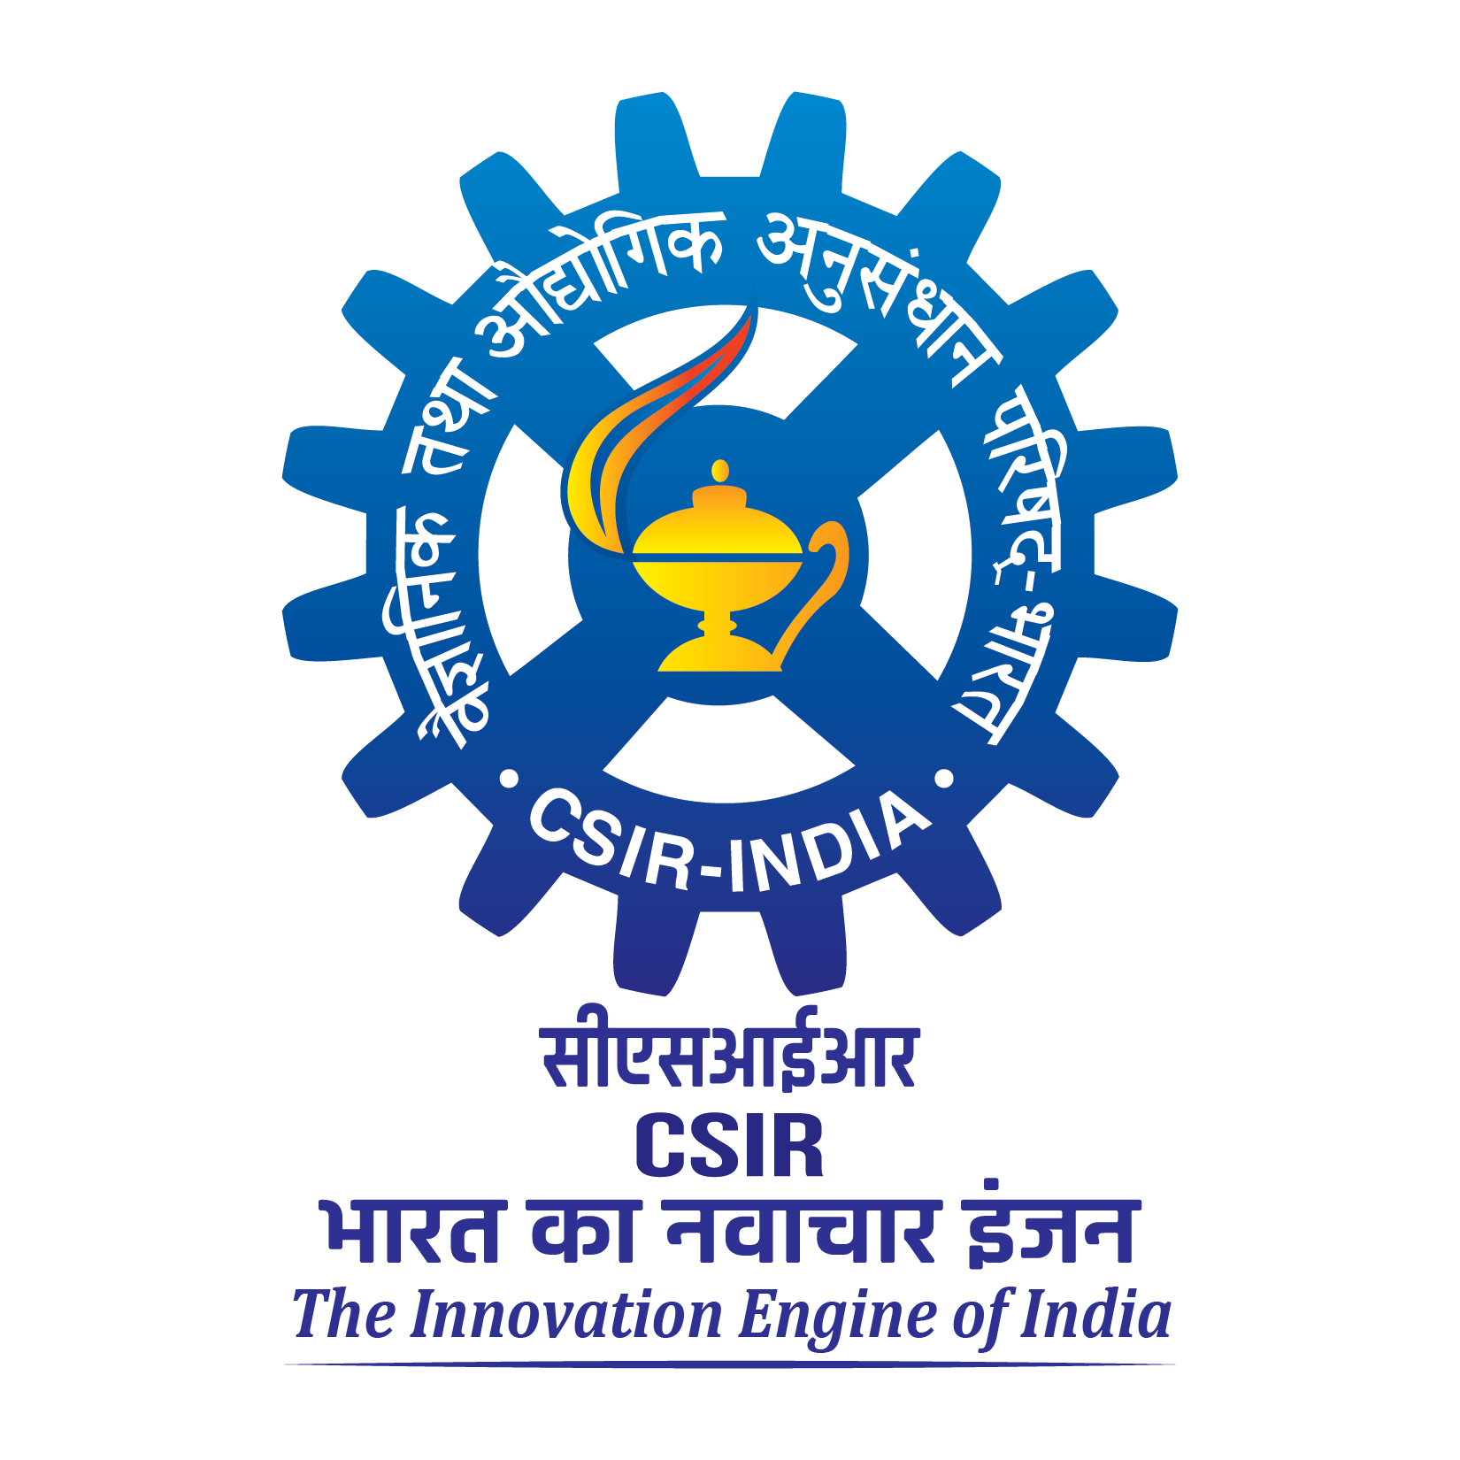
CSIR-CENTRAL GLASS & CERAMIC RESEARCH
INSTITUTE, KOLKATA – 700 032
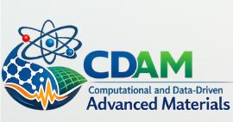

COMPUTATIONAL AND DATA-DRIVEN ADVANCED MATERIALS (CDAM)
Date: April 07, 2026
Venue: A.P.C Roy Seminar Hall, CSIR-CGCRI-Kolkata

Day-1
Time | PROGRAM
08:30 hrs–09:15 hrs | Registration and High Tea
Inaugural Session
09:15 hrs -09:20 hrs | Ceremonial lighting of a lamp to mark the beginning of an event
09:20 hrs –09:30 hrs | Welcome Address and Setting the Context, Prof. Bikramjit Basu, Director, CSIR-CGCRI and Patron, CDAM 2026
09:30 hrs –09:40 hrs | Introductory Remarks by Guest of Honour, Dr. G. K. Patra, Director, CSIR-4PI, Bangalore
09:40 hrs –09:50 hrs | Introductory Remarks by Chief Guest, Prof. Tanusri Saha Dasgupta, Director, SNBNCBS, Kolkata
09:50 hrs –09:55 hrs | Vote of thanks by Dr. Indrajit Tah
09:55 hrs –10:00 hrs | Group Photo Session
Technical Session 1
10:00 hrs –10:30 hrs | Prof. Tanusri Saha Dasgupta, Director, SNBNCBS, Kolkata  Title: Intelligent Materials Design & Understanding: ML in action
10:30 hrs –11:00 hrs | Prof. Srikanth Sastry, JNCASR, Bangalore  Title: Seeing through glass failure: Prediction of fatigue failure in glasses from damage quantification and machine learning
11.00 hrs –11:30 hrs | Dr. G. K. Patra, Director, CSIR-4PI, Bangalore  Title: Becoming a Scientist in the Age of AI: Opportunities in Advanced Materials Research
11:30 hrs –12:00 hrs Inauguration of the Computational Materials Section at CSIR-CGCRI
&
Tea Break (at K D Sharma Hall)

Technical Session 2
12:00 hrs –12:25 hrs | Prof. Priya Mahadevan, SNBNCBS, Kolkata  Title: Determining rules for distortions in complex systems – case of hybrid perovskites
12:25 hrs -12:50 hrs | Prof. Suman Chakrabarty, SNBNCBS, Kolkata  Title: Navigating Pathways in Free Energy Landscape: Adaptive (Machine) Learning Strategies in Molecular Simulation
12:50 hrs –13:15 hrs | Prof. Sankha Mukherjee, IIT Kharagpur  Title: From Configurational Disorder to Anharmonic Lattice Softening:  Mechanistic Origins of Superionic Conduction in Ge-Free Sulfide Solid  Electrolytes
13:15 hrs –14:30 hrs Lunch Break
(at K D Sharma Hall)
Workshop Session
14:30 hrs –15:45 hrs | Hands-on Workshop by Prof. Srikanth Sastry, JNCASR Bangalore  Title: Aneesur Rahman and the beginnings of molecular dynamics
15:45 hrs – 16:00 hrs | TEA BREAK
16:00 hrs –17:15 hrs | Hands-on Workshop by Prof. Gautam Anand, IIT- BHU  Title: Entropy as a computational design tool for structure-property correlations in materials
17:30 hrs -18:30 hrs | Poster Session & Evaluation
Date: April 08, 2026
Venue: A.P.C Roy Seminar Hall, CSIR-CGCRI-Kolkata

Day-2
Time | PROGRAM
09:15 hrs – 10:00 hrs | Inauguration of Refurbished Administrative Enclave at CSIR-CGCRI
Technical session 3
10:00 hrs –10:30 hrs | Prof. D. D. Sarma, IISc Bangalore  Title: Synergy between experiment and theory in materials science: A few examples
10:30 hrs –11:00 hrs | Prof. Partha Pratim Chakrabarti, IIT Kharagpur  Title: Artificial Intelligence: The Emerging Face of Modern Scientific Discovery and Technological Innovation
11:00 hrs –11:30 hrs | Prof. Asim Tewari, IIT Bombay  Title: The Changing Role of Human Researchers in the Age of AI-Enabled Materials Discovery
11:30 hrs -12:00 hrs Inauguration of the Knowledge Resource Center at CSIR-CGCRI
&
Tea Break (at K D Sharma Hall)
Technical Session 4
12:00 hrs –12:30 hrs | Prof. Smarajit Karmakar, TIFR, Hyderabad  Title: Yielding Transition in Amorphous solids: Effect of Fragility
12:30 hrs –13:15 hrs | Panel discussion on “Emerging Computational tools for accelerated discovery of materials”
13:15 hrs –14:15 hrs Lunch Break
(at K D Sharma Hall)
Workshop Session
14:15 hrs –15:30 hrs | Hands-on Workshop by Prof. Asim Tewari, IIT Bombay  Title: Hands-on Tutorial on Cloud-Based Open-Source Finite Element Analysis and AI-Driven Topology Optimization
15:30 hrs – 15:45 hrs | Tea Break
15:45 hrs –17:00 hrs | Hands-on Workshop by Dr. Bishwajit Ganguly, Emeritus Scientist, CSIR-CGCRI, KolkataTitle: Computational Methods for Exploring Structural and Electronic Effects in Molecules and Materials
Valedictory session
17:00 hrs –17:10 hrs | Concluding Remarks by Mr. Jyotirmay Sikder
17:10 hrs -17:25 hrs | Poster Prize distribution
17:25 hrs -17:30 hrs | Vote of thanks by Mr. Ankush Pratap Singh

